Pan-Armenian Forum of Young Businessmen

July 15-22, 2016
Yerevan, Stepanakert

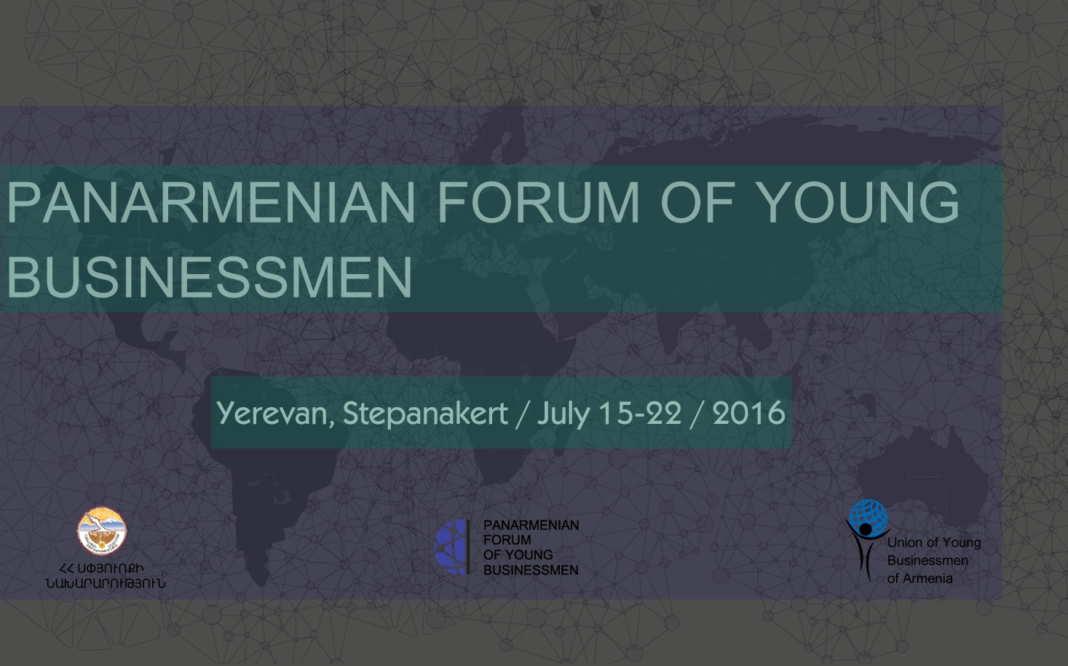

The first Pan-Armenian Forum of Young Businessmen will take place from 15 to 22 July 2016 in Yerevan and Stepanakert. The forum is organized by the Union of Young Businessmen of Armenia with the support of the Ministry of Diaspora of the Republic of Armenia.

If you:

- are a young Armenian
- have a business
- want to get acquainted with the business climate in Armenia
- want to obtain new partners
- want to exchange experience and knowledge
- want to initiate joint business projects
- want to visit the leading companies of Armenia and Artsakh
- want to visit historical and cultural sites

then this forum is for you.

The forum will gather young Armenians doing business in different parts of the world. It will help create a unique platform for cooperation and help the young Armenians obtain partners, which can be crucial for participants in their business and personal lives.

8 days in Armenia and Artsakh

Explore your homeland,
Establish business contacts,
Make your business grow.

The working languages of the forum are Armenian, English and Russian.
To participate in the Pan-Armenian Forum of Young Businessmen, young businessmen should register in advance by clicking https://goo.gl/BrDz7Q.
The participants only cover their travel and accommodation fees.
The organizers of the forum will send other information and details on a regular basis.
The deadline for submitting applications is June 15, 2016.

Union of Young Businessmen of Armenia

Address` Yerevan, Shirak 74/2
Tel.`(+374 10) 42 72 15, (+374 98)07 19 19
Official website`www.Uyba.am
Email ՝ uybarmenia@gmail.com, info@uyba.am
Official facebook page`
https://web.facebook.com/UnionofYoungBusinessmenofArmenia/

Project coordinator` Mikael Mikaelyan
Tel.`(+374 77) 149 489
Email` uyba.mikaelyan@gmail.com

